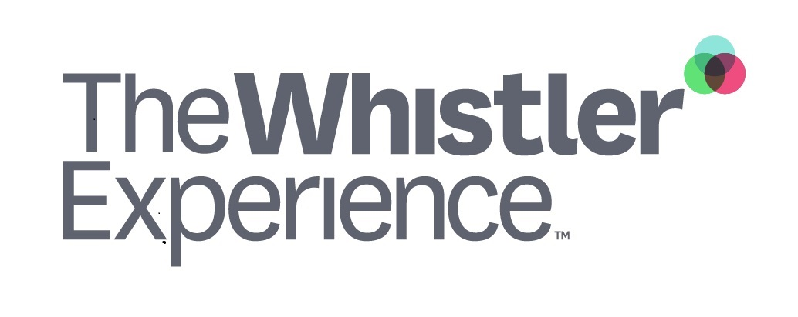

2021/22 The Spirit Pass Agreement

S A M P L E (100% end-of-season bonus)

Note to reader
This contract sample allows you to turn the Spirit Pass into a true Recruitment & Retention tool. The sample is based on the assumption that the cost of the Spirit Pass will turn into an end-of-season benefit.
We recommend reviewing the contract to align it with your company goals and practices and replacing COMPANY with your organization’s name and logo.

(COMPANY LOGO)
2021/22 The Spirit Pass Contract

S A M P L E (100% end-of-season bonus)

COMPANY wants to help you enjoy and make the most of your time in Whistler. The following agreement describes our investment and your commitment for the 2021/22 winter season.

- We will purchase a Spirit Pass on your behalf which represents a 100% allowance. The allowance of $1,018 will appear on the CRA T4 as income.
- The Spirit Pass is the property of COMPANY. If you cease employment with COMPANY prior to March 31, 2022, you will be required to pay COMPANY a prorated amount in respect of the allowance awarded depending on your termination date (see paragraph 3).
- If you stay with COMPANY until March 31, the Spirit Pass allowance will turn into an end-of-season bonus. If your employment ceases prior to March 31, 2022, you will repay the following amounts

If employment ceases… | Amount owed to COMPANY for Spirit Pass
Prior to Dec 31, 2021 | $1,018
Between Jan 1 and Jan 31, 2022 | $750
Between Feb 1 and Feb 28, 2022 | $600
Between Mar 1 and Mar 31, 202 | $400

- If you cease employment with COMPANY and would like to retain the Spirit Pass, you will need to provide proof to the COMPANY with a local organization that participates in the 2021/22 Whistler Experience program.

- If you DO NOT take the Spirit Pass, you can receive reimbursement of up to $1,018 plus GST for costs associated with any other health and wellness program that benefits you directly and personally. Invoices for such alternative health and wellness programs must be submitted to COMPANY no later than April 30, 2022 so that reimbursement can proceed in a timely manner.
If you cease employment with COMPANY prior to March 31, 2022, you will be required to pay the COMPANY a prorated amount in respect of the allowance awarded that is dependent on the termination date (see paragraph 3 above).

Acceptance

By signing this agreement I agree to abide by the terms and conditions of the 2021/22 Spirit Pass Contract and the rules of the Whistler Experience and Whistler Blackcomb Spirit Passholder Terms and Conditions. I understand that the mountains can be a dangerous environment and agree to indemnify COMPANY from any action that occurs on the mountains while I am using the Spirit Pass.

Name Signature Date

