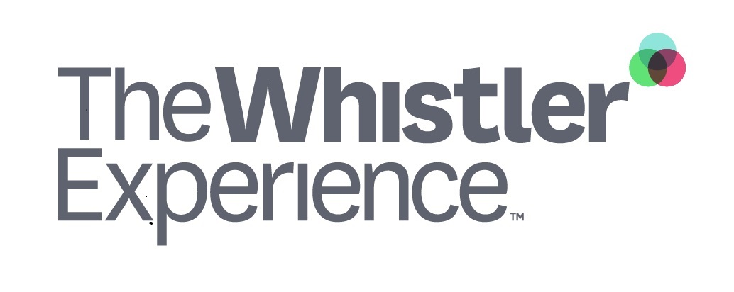

2022/23 The Whistler Experience® Training Contract

S A M P L E

Note to Employer/Reader
This sample contract allows you to use The Whistler Experience® training as a true Recruitment & Retention tool.
Please note this sample contract assumes that 100% of Whistler Experience® training will turn into an end-of-season benefit. We recommend customizing the contract (see highlighted areas) to align it with your company goals and practices.
- Replace COMPANY with your organization’s name and logo
- Decide on what Whistler Experience training each employee receives in the 2022/23 season
- Determine pro-rated amounts (if you wish) if employment ceases before the end of season

(COMPANY LOGO)
2022/23 The Whistler Experience® Training Agreement

S A M P L E
We would like to invest in your professional development AND help you build skills for your career here in Whistler, or wherever your career path takes you. The following agreement describes our investment and your commitment to us for the 2022/23 season.
- COMPANY offers you (the employee) the opportunity to participate in the following Skills development courses as a part of The Whistler Experience® training:
Mark included courses | Course name | Value
 | Management 101: Conflict Resolution | $39.00 (+Tax)
 | Management 101: Performance Management for New Leaders | $39.00 (+Tax)
 | The ABC's of Service Excellence | $29.00 (+Tax)
 | Gender Diversity Basics | $29.00 (+Tax)
Total value of skills development training (including $40.00 Admin fee)

- Provided you are still employed with COMPANY at March 31, 2023, the training cost will turn into an end-of-season bonus. If your employment ceases prior to this date, you will repay the following amounts:
If employment ceases…* | Amount owed to COMPANY for Whistler Experience® training
Prior to Dec 31, 2022 | Add amounts
Between Jan 1 and Jan 31, 2023
Between Feb 1 and Feb 28, 2023
Between Mar 1 and Mar 31, 2023

Acceptance

By signing this agreement I, <EMPLOYEE NAME> agree to abide by the terms and conditions of the Whistler Experience® Training Contract.

Name Signature Date

