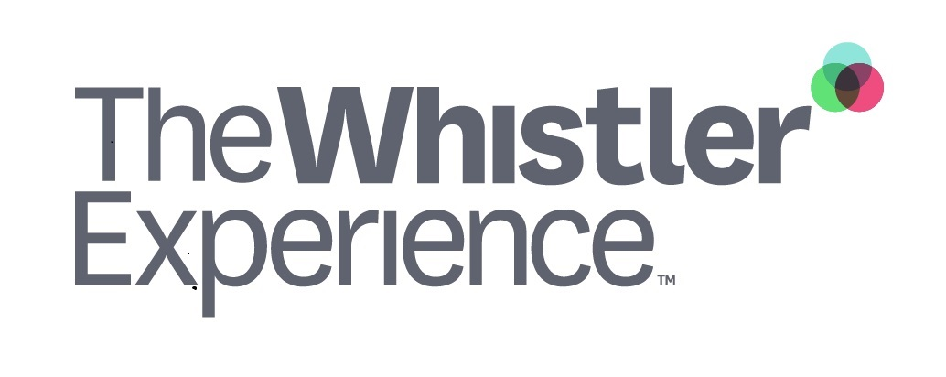

2023/24 The Spirit Pass Agreement

S A M P L E
(100% OR 50% end-of-season bonus)

Note to Employer/Reader
This sample contract allows you to use the Whistler Blackcomb (WB) Spirit Pass as an attractive Recruitment & Retention tool.
Please note this sample contract assumes that the company will pay for either 100%, or 50% of the WB Spirit Pass turning this benefit into an end-of-season bonus.
We recommend customizing the contract (see highlighted areas) to align it with your company goals and practices.
- Replace COMPANY with your organization’s name and logo
- Choose the investment option as it relates to the company’s offer; paying for 100% or only a portion of the WB Spirit Pass.
- Determine pro-rated amounts (if you wish) should employment cease before the end of season

(COMPANY LOGO)
2023/24 The Spirit Pass Contract

S A M P L E

We want to ensure you enjoy, and make the most of your time here in Whistler. The following agreement describes our investment and your commitment for the 2023/24 winter season.

- As a part of COMPANY employment benefits package we will purchase a Whistler Blackcomb Spirit Pass on your behalf which represents a 100% allowance. The allowance of $1,115 will appear on the CRA T4 as income.

- As a part of COMPANY employment benefits package we will purchase a Spirit Pass on your behalf, 50% of which represents an allowance and 50% of which represents an advance. The allowance of $___ will appear on the CRA T4 as income. The advance will be deducted equally over 8 pay periods from December 15, 2023 to March 31, 2024.
- The Spirit Pass is the property of COMPANY. If you cease employment with COMPANY prior to March 31, 2023, you will be required to pay COMPANY a prorated amount in respect of the allowance awarded depending on your termination date (see paragraph 3).
  - Please note your WB Spirit Pass will remain hotlisted (inactive) until you are employed with another organization participating in the 2023/24 Whistler Experience program; and the full cost of the WB Spirit Pass is reimbursed to COMPANY either by the employee or the new employer.

- Provided you are still employed with COMPANY at March 31, 2024, the WB Spirit Pass will turn into an end-of-season bonus. If your employment ceases prior to March 31, 2024, you will be required to repay the following amounts:

If employment ceases… | Amount owed to COMPANY for Spirit Pass
Prior to Dec 31, 2023 | $1,115
Between Jan 1 and Jan 31, 2024 | $825
Between Feb 1 and Feb 28, 2024 | $650
Between Mar 1 and Mar 31, 2024 | $425

- If you choose NOT to purchase the Spirit Pass, we are happy to offer you the wellness bonus of up to $1,115 (+Tax) for costs associated with any other health and wellness program directly benefiting you personally. Invoices for such alternative health and wellness programs must be submitted to COMPANY no later than April 30, 2024, so that reimbursement can proceed in a timely manner.

Acceptance

By signing this agreement I, <EMPLOYEE NAME> agree to abide by the terms and conditions of the 2023/24 Spirit Pass Contract and the rules of the Whistler Experience and Whistler Blackcomb Spirit Pass holder Terms and Conditions. I understand that the mountains can be a dangerous environment and agree to indemnify COMPANY from any action that occurs on the mountains while I am using the Spirit Pass.

Name Signature Date

